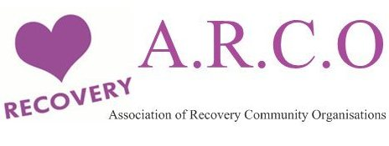
Association of Recovery Community Organisations (ARCO)
ARCO Toolkit looks at how to go about setting up an RCO – from the core principles that inform it to the practicalities of creating and sustaining an organisation. It gives CLEAR GUIDANCE & Steps for creating a Recovery Community Organisation
Criteria = RCOs must have a majority of board members, managers, staff and volunteers drawn from the community. Their accountability to the Recovery Community. In most cases, this means being an independent, stand alone, non-profit organisation. E.g.; an RCO may work closely with treatment providers, criminal justice or the NHS - but must be independent of them in terms of their governance.
Each organisation has a mission that reflects the issues and concerns of their community.
One of the founding principles of RCOs is embracing all pathways to recovery.
All RCOs share three core principles: Recovery Vision, Authenticity of Voice and Accountability to the Recovery Community.
RCOs provide an organised way for people to give back to their communities through volunteering and paid service to others seeking recovery.
RCO’s use participatory processes
Recovery Community Organisations: Core Strategies
Promote recovery-focused and oriented values and communities.
Each organisation determines the mix and priority given to each of these core strategies:
Public Education and Awareness
Policy advocacy
Peer-based and other recovery support services and activities
Being a member of ARCO gives orgs the opportunity to build relationships with local, national and international recovery community organisations.
The Association of Recovery Community Organisations (ARCO) unites and supports the growing network of local, regional and national recovery community organisations. ARCO links recovery community organisations and their leaders with local and national allies, and provides training and technical assistance to groups. All recovery community organisations that are led and governed by the recovery community are welcome to join.

