Faces & Voices of Recovery UK – Annual Report 2015/16
Faces & Voices of Recovery UK
Annual Report and Accounts 2015/16
Charity Number: SC043961
www.facesandvoicesofrecoveryuk.org
Introduction

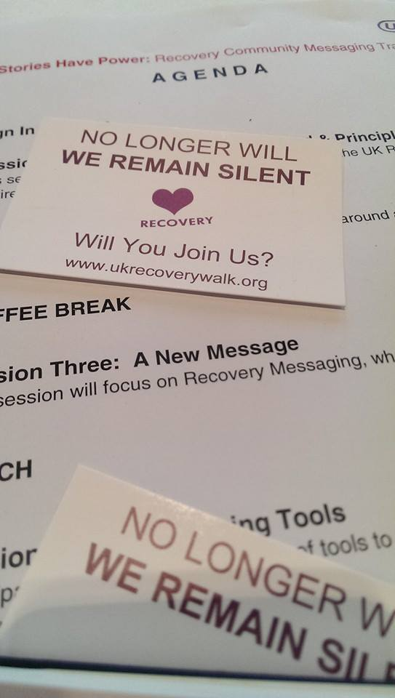
The Faces & Voices of Recovery UK’s Annual Report and Financial Summary for 2015/16 sets out for our members, supporters and the general public, what we have achieved in the last year, and our aspirations for the future.
We are delighted and encouraged by your continued support over the last 12 months. Our Annual Report is our one opportunity each year to draw attention to the work we are proud of and to share with you our hope & optimism going forward.
More people than ever have got behind us; at the last count we had over 1,800 individual members from across the UK. In addition, five organisations have signed up to become members of The Association of Recovery Community Organizations (ARCO UK).
http://www.facesandvoicesofrecoveryuk.org/association-of-community-recovery-organisations-a-r-c-o/
The feedback from ARCO UK members is that they feel informed, encouraged, inspired and strengthened by the guidelines in our toolkit.
http://www.facesandvoicesofrecoveryuk.org/wp-content/uploads/2017/03/Resources_Recovery-Community-Organisations-Updated-2015.pdf
We are certain that ARCO reflects the maturation of the still embryonic recovery movement in the UK and we would very much welcome your applications for membership.
Visits to our website are continuing to increase, with both new and returning users, and thousands of you are also engaging with us on our social media platforms which again give us great inspiration and faith in our future. We thank you again for your continued support in this area.

A Message from our Chair of Trustees

First and foremost I want to pay tribute to our 300 amazing volunteers, my fellow Trustees and our Chief Executive Anne-Marie Ward. It is their passion, commitment and determination that enables our Charity to continue to deliver its mission in an increasingly challenging environment.

This last year we have continued to see a diminishing treatment sector as money flows out of the system, the highest levels of drug related deaths ever recorded and 97% of people with hepatitis C remaining untreated despite there being pharmaceuticals available that can effectively eradicate the virus.

Against the context that the state can no longer guarantee effective, high quality treatment for all, it is noticeable that our membership has increased and the demand for our advocacy and training services continues to grow. As the largest member organisation in the UK and custodians of the famous annual Recovery Walk we occupy a unique and vital place in the recovery landscape, providing a visible beacon of hope and optimism. One of the most delightful aspects of my role is hearing the individual stories, such as one young man whose first day clean was spent with over 5,000 members of the Recovery Community at the Manchester Walk - nothing comes even close to such tangible and visible evidence that recovery can and does happen! His story is just one of many 1,000s of individuals and families who engage with and are inspired by the Charity each year.

On behalf of the Recovery Community we serve, we are incredibly grateful to our sponsors but we urgently need more to step forward as this last year has been particularly challenging financially. What stands out most in the pages of this report is how we achieve so much with so little and I would appeal to the treatment sector, the organisations and individuals who care about and love Recovery to reach out and continue to support the Charity in the coming year.

Jon Royle 2016.

Our trustees, members and supporters felt that both our mandate and our primary purpose are best described by the name Faces and Voices of Recovery UK (FAVOR UK) so in May 2015 we were delighted to announce our name change from the UK Recovery Walk charity to now be known as FAVOR UK. Being originally inspired by the work of FAVOR in the US.
During the last three years we have undertaken an increasing amount of recovery advocacy work, supporting individuals and challenging the institutions they are working with to serve them better. We have continued to support and promote international Recovery Month each September in partnership with our Faces and Voices of Recovery friends in the US, Canada, South Africa, Japan, Brazil and Austraila.
We are a policy advocacy organisation, addressing issues of stigma, discrimination, social justice and service access. We achieve this by delivering messages of hope to the cultures of addiction within our systems and treatment.
Our aim is to save lives and promote health and wellbeing by encouraging, empowering and educating people in recovery from addiction and those affected by addiction.
To achieve this, we:
- Raise funds to support our work
- Promote and co-produce a national UK Recovery Walk and Recovery Conference each year
- Give a face and voice to recovering people
- Provide support and information to support to get the help they need to enter recovery and progress their lives, free from addiction.
- Promote a wide range of recovery activities during Recovery Month and throughout the year
- Work in partnership with local, regional and national organisations such as local authorities, treatment services and Public Health England to highlight and promote recovery

FAVOR UK is the only organisation in the UK with an explicit mission to respond to the organisational and leadership development needs of grass roots addiction recovery community organisations, and to develop and unify addiction recovery advocacy in the UK. FAVOR UK has a high level of brand recognition and the support of the recovery community in the UK. The charity’s board members contribute to an international advisory body selected by Faces and Voices of Recovery in the United States to foster the development of networks of support between recovery community organisations internationally.

UK Recovery Walk
Each September during Recovery Month Recovery Communities worldwide are encouraged to spread the message that prevention works, treatment is effective, and recovery from addiction is a lived reality in millions of people’s lives.
The UK Recovery Walk takes place each September to raise awareness of substance use disorders and RECOVERY from addiction. The aim of The UK Recovery Walk is to celebrate the achievements of individuals in recovery, and acknowledges the work of prevention, treatment, and recovery support services.

What we aim to demonstrate through the UK Recovery Walk (and our ongoing advocacy work) is:
The Walks are an opportunity for us
to announce our presence and,
we are now mobilising
and organising
our community.
- There are viable and varied recovery solutions for alcohol and other drug problems.
- We are examples of real people who illustrate the diversity of those recovery solutions.
- We can challenge any public attempt to dehumanise, objectify and demonise those with alcohol and other drug problems.
- Advocate for variety, availability, and quality of local/regional treatment and recovery support services.

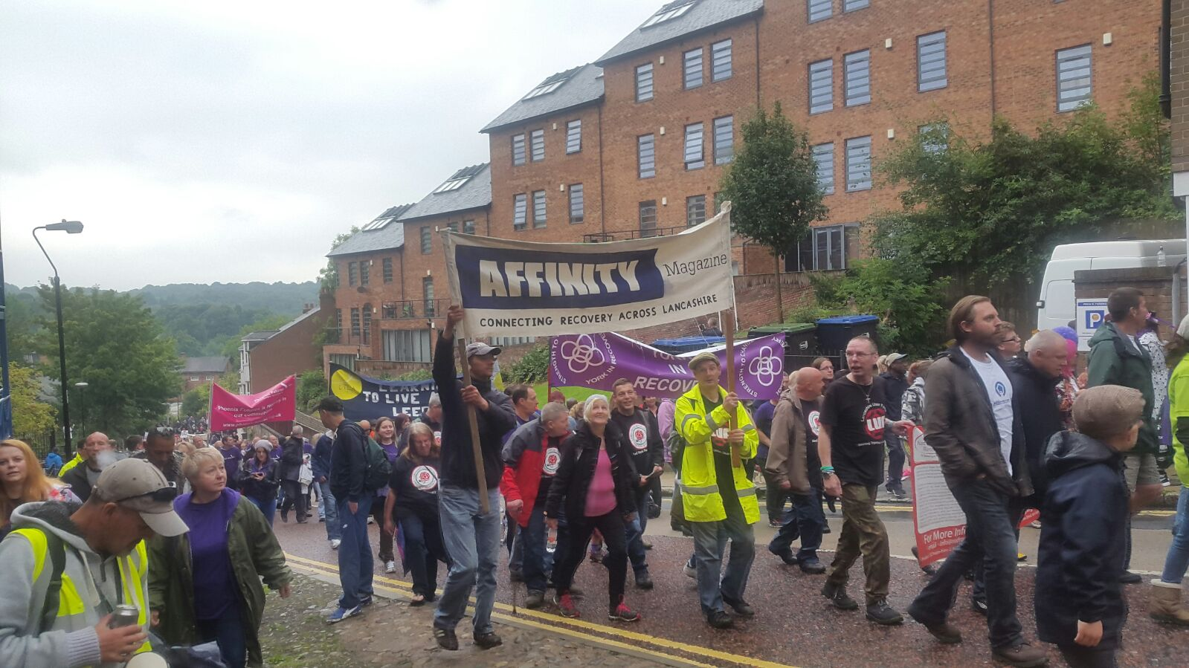

2014 - 2017 Strategy (Short
Our Vision

UKRW exists to support the development and effectiveness of the UK Recovery Movement.
We will achieve this by:
- Coordinating recovery advocacy activity across the UK
- Organising and supporting local and national advocacy campaigns
- Providing resources and information to facilitate an increase in the visibility of recovery
- Training people in recovery in order to foster effective advocacy skills

We have identified the following seven goals to further our vision and they form the basis of the charity’s strategic plan for 2013-17:
- Co-produce the annual UK Recovery Walk with local partners
- Unify the recovery advocacy movement through coordinated national and local action and effective, targeted communication
- Support the expansion and growth of grass roots organisations by enhancing awareness of different pathways to recovery
- Further develop the Association of Recovery Community Organisations to support local action and unify advocacy agendas
- Develop and disseminate messages for the recovery advocacy movement to engage the public and policy makers at national and local levels
- Develop non-stigmatising, evidence based narratives on prevention, treatment and recovery for Public Information Kits
- Unify the recovery advocacy movement by developing a consensus on issues for national and local focus

If you would like to see the full version version of our 3-year strategy or have any questions or comments regarding our work please do not hesitate to get in touch with us at info@facesandvoicesofrecoveryuk.org

2014 - 2017 Strategy (Short
Review of 2015-16

UK Recovery Walk 2015
The planning and organising of the walk with last year’s host, Durham Recovery Forum (DRF), was an opportunity for us to put into action and fine tune the two-tier planning structure in the spirit of inclusivity and co-production. You can read about the process and how it developed here.
http://www.ukrecoverywalk.org/the-6th-uk-recovery-walk-greater-manchester/
This two-tier planning process has been taken forward as a blueprint for development and has been again adapted and tuned to suit the talents and skills with this year’s host committee in Halton. We have utilised and developed these participatory processes and the fine tuning allows each year’s host to shape and encourage the directions and theme to represent them clearly. This year’s theme having just been agreed as dare to dream.

Advocacy Conference 2015
Primary theme = Spiritual pathways to recovery
Secondary theme = Family’s in recovery
Our conference this year focused on how many people in recovery regard “spirituality”, however that is defined, to be a vital component of their recovery. We discussed rather than embracing and working with this, spiritual pathways to recovery are often still overlooked, deliberately ignored and even now derided and scoffed at in mainstream treatment. The National Institute for Health and Clinical Excellence in its clinical guidance for drug treatment in 2007, for example, advises that all addiction treatment “should routinely provide people who misuse drugs with information about 12 step fellowships” but in reality this does not happen.
The membership of Faces & Voices of Recovery UK represent a broad spectrum of spiritual and secular recovery pathways, family members and friends of recovery. The theme for the 2015 FAVOR UK charity conference in 2015 was spiritual pathways to recovery, providing an opportunity to celebrate their contribution to the UK Recovery Community and stimulate a bigger debate about the role of contemporary spirituality in recovery and appropriate responses by treatment services.
Christin Duncan the CEO rom Scottish families affected by alcohol and other drugs also introduced our secondary theme which will become the main focus for the 2016 conference families in Recovery.

See the link below to the first presentation of the day and follow the links to the rest of the presentations on the day from here.

https://www.youtube.com/watch?list=PLZ4DEt4iNXtKZGDi2-YRFLDNyfCDiq1MJ&v=kUSZLZaYPRI

Training and education
Again we were able to further develop, update and deliver two training courses this year, with manuals and booklets to accompany them, offered freely: the first being Our Stories have Power training with accompanying Questions and Answers Booklet; and secondly The UK Recovery Coach Manual, complete with suggested training exercises and service specifications. We know that these documents are useful and well received, as they have been downloaded many thousands of times from our website. We are grateful to have had the opportunity to work with some very dedicated and inspiring people when producing them. These documents can be downloaded here:
http://www.facesandvoicesofrecoveryuk.org/wp-content/uploads/2017/04/Questions-and-Answers-Booklet-Updated-2015-1.pdf
http://www.facesandvoicesofrecoveryuk.org/wp-content/uploads/2017/03/UK-Recovery-Coach-Manual-V2-Pub-1-Updated-2015.pdf
Recovery Month 2015
In September 2015 we marked the 26th anniversary of International Recovery Month. Throughout September thousands of people across the UK organised local events celebrating the fact that recovery from addiction to alcohol and other drugs is a lived reality in their lives. Recovery Month celebration events have grown beyond what anyone could have predicted here in the UK with an estimated 140 events taking place across the country in 2015. Local recovery celebration events that once welcomed a few dozen brave participants grew into the hundreds and then into the thousands. Each one is stepping forward to challenge the degrading public stereotypes attached to addiction – and together stepping forward to put a public face on addiction recovery. It is important to recognise why public education and policy advocacy is so important. All over the UK we are, as people in recovery, living lives of restored health and community service who, even as little as 50 years ago, would have died or been subjected to jails & other institutions.

Give it Back campaign
The ‘Give it Back’ campaign goes from strength to strength. Give it Back now takes place every September, during Recovery Month, and is a national and regional media campaign where we will support members with their own local media campaigns to showcase examples of individuals and groups of people in long term recovery, voluntarily giving something back to their local communities. Please get in touch is we can be of service with this.
Fundraising
A special thanks to our sponsors for 2014 -15 CRI, Lifeline, Phoenix Futures, DISC, Trusthouse & Durham County Council without whom none of it would have been possible. We know we did them and of course you – the families and people in recovery proud!
Looking forward to 2016/17
We are also incredibly grateful to the many small significant events and donations that are being coming in via the website. We would like to take this opportunity thank everyone who created fund raising events and donated online. Every effort small and large is to be celebrated and we are very grateful for everyone’s support and participation in the walk and the charity this year.
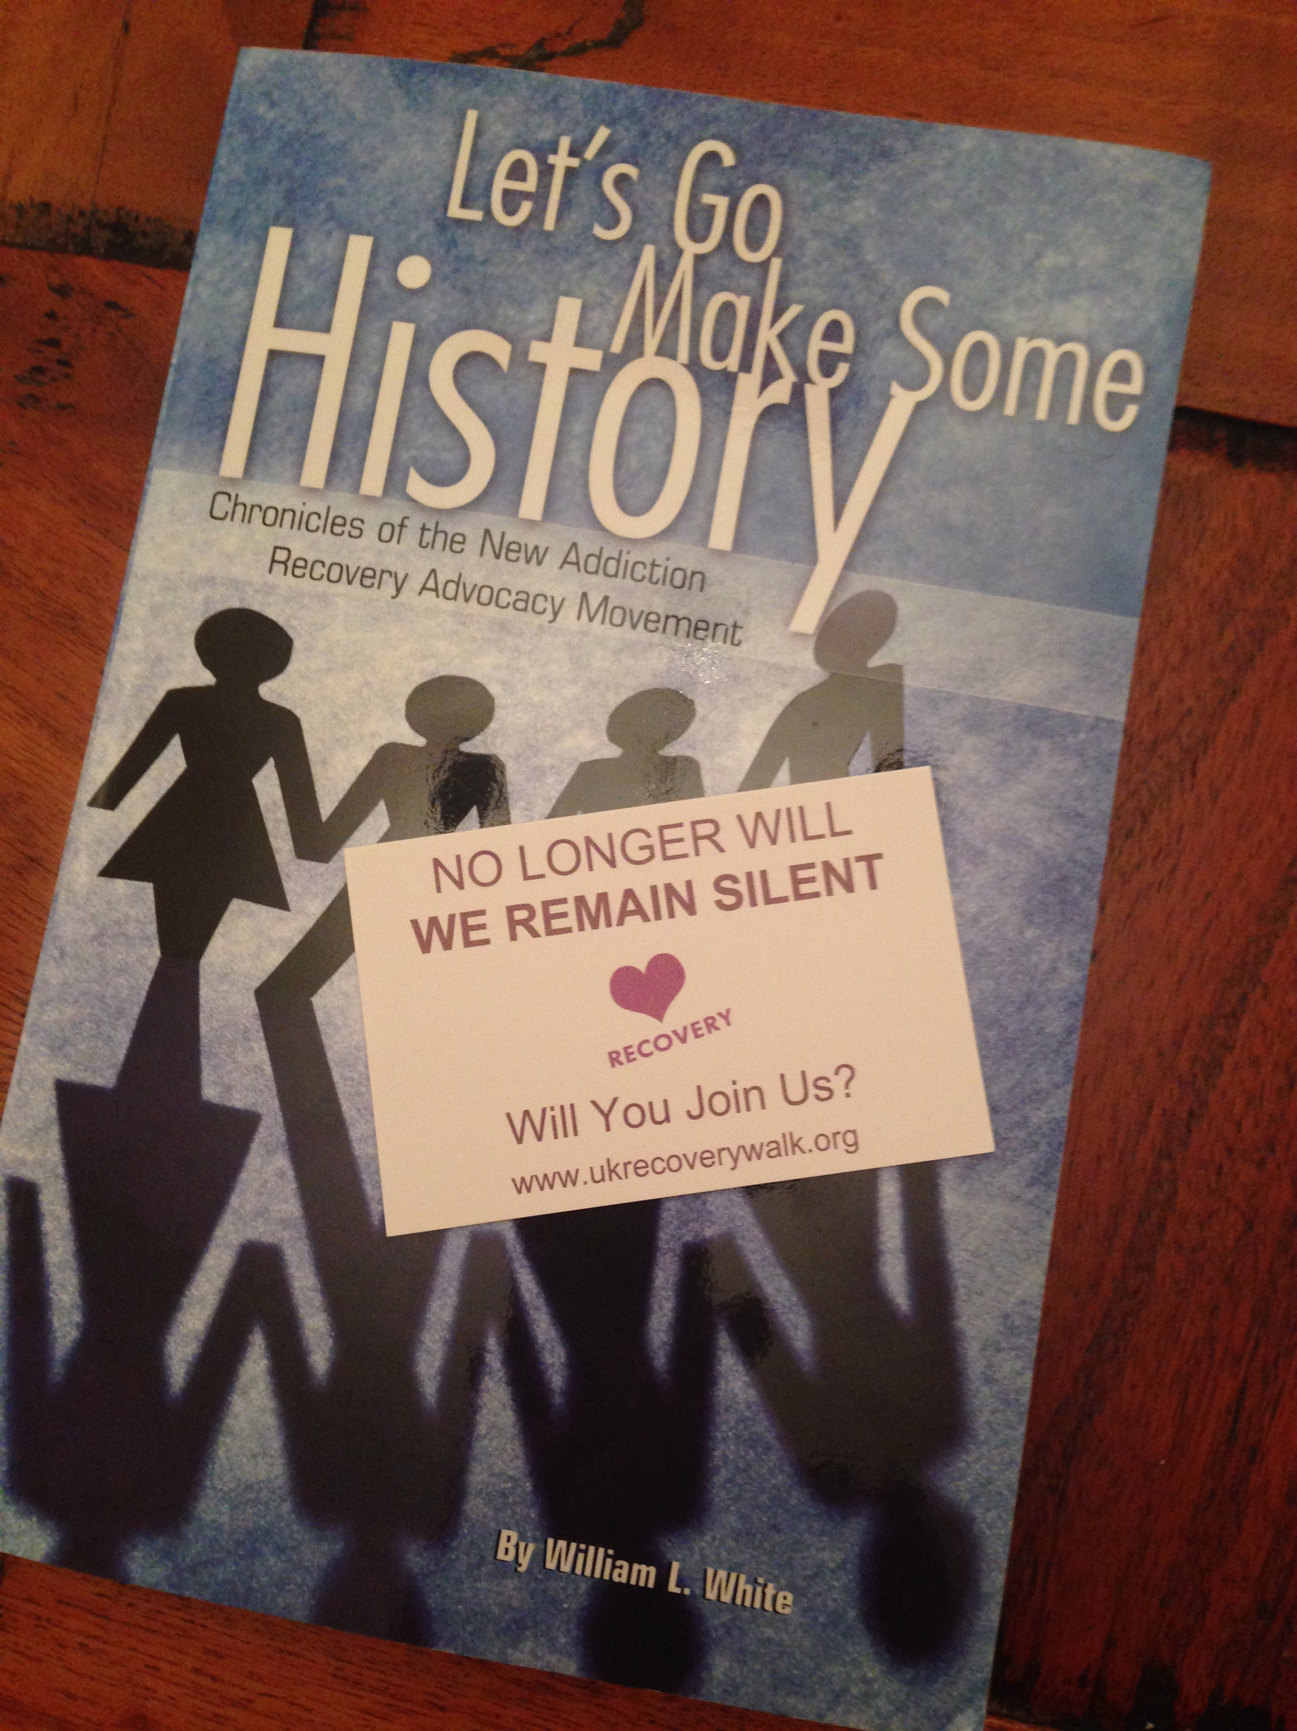
This year’s Recovery Month in September 2016 is also an opportunity for us all to honor the work of the many people and agencies that work hard every day in the area of both prevention and treatment. One of the ways we can do this is by wearing our Courage and Bravery badge with pride. It’s also a great way for us to raise awareness and some funds. Please click on the link here to get your courage and bravery badge:
https://mydonate.bt.com/events/braverycourage/109609
https://mydonate.bt.com/events/braverycourage/109609

Please take the time to review our My BT donate page where you also can raise funds or encourage others to create events and get fundraising:
https://mydonate.bt.com/charities/facesvoicesofrecoveryuk

Advocacy update
We are advocating all over the UK for a variety of individual personal cases, but are continually constrained as lack of capacity and resources prevent us from reaching al those who ask for out help. This continues to frustrate and prevent FAVOR UK from meeting the needs of our community. In response to concerns raised by our members in the West Midlands following the announcement of plans to close a local residential rehabilitation facility without any consultation with service users and their families, we launched an advocacy campaign in 2014 which involved Freedom of Information requests, correspondence with local elected members and teleconferences with the local Director of Public health. Due to ongoing concerns about the future of the facility and the lack of any meaningful service user involvement in decision making, we will be continuing our work in this area in 2016/7, including meeting with local FAVOR UK members and service commissioners. The facility is still open today and there are plans for a full formal consultation about its future. You can read more about the background to the ongoing campaign here:
http://www.facesandvoicesofrecoveryuk.org/summerhill-campaign/

Faces & Voices of Recovery UK is a small organisation and a rolling team of over 300 volunteers who commit and deliver every year. As a charitable organisation we recognise our important responsibilities towards our beneficiaries, funders, donors, supporters, staff and the public. With such responsibility we must follow good governance, ethical best practices, be financially well managed and focused on delivering our mission for each individual for whom we provide advocacy and support. As such we need to attract the most talented individuals who are capable of inspiring co production and working often with only a promise of gratitude. Our continued failure to attract core funding continues to frustrate and inhibit our development.

We are however dedicated to building lasting relationships built on trust with each of our partners & sponsors and in doing so we embrace transparency and accountability in all aspects of our work. We are also dedicated to growing our organisation, and building a society where mental wellbeing really matters.
It is undoubtable that Austerity’ policies are harming the economy, have created a cost of living crisis and are putting our public & charitable services under intense pressure. Austerity is damaging people’s lives and health, hitting low-paid workers hard, causing misery, risking a lost generation of young people who can’t find work, and creating greater levels of income inequality, which is bad for the economy, for those on the lowest incomes, cutbacks to our alcohol & other drug services and for society in general.
There were 3,346 drug poisoning deaths registered in England and Wales in 2014, the highest since comparable records began in 1993. In Scotland there were 613 drug-related deaths in 2014, a 16% increase on the previous year and the highest number recorded since the current recording system began in 1996.
We continue to see the challenges of austerity for public services, which has served to highlight the many challenges still facing our sector, as well as the opportunities. In addition, the growth of localism and regional devolution at scale and pace across England may also bring unprecedented challenges to the commissioning of prevention, treatment and recovery support services. We will continue to focus on ensuring that shrinking financial resources are invested in effective and evidence based interventions to prevent and reduce alcohol and drug related harms, treat addiction and support recovery.
I believe we can conclude our AGM for this year with a sense of dignity and positivity for surving and thriving another year with an eye on the future. Clearly, the charity's independence, integrity and growing role in a dramatically changing world is an important one. FAVOR UK has an unprecedented opportunity to chart a new course and provide better advocacy for people in recovery, their families and the wider community.
In conclusion, I would like to take the opportunity to thank all of you, our members, supporters and trustees for your hard work and insightful contributions throughout 2015-16. Your ongoing involvement and guidance is vital to ensure that our very limited resources for advocacy development are still invested for maximum impact across the UK.

Annemarie Ward, July 2016

