Application for hosting the 2018 recovery walk

Dear Anne Marie
I am writing to put an Expression of Interest in for hosting the UK Recovery Walk 2018 in Sheffield.
Why We Want to Host the Recovery Walk 2018
The SURRG brings together representatives from the recovery community along with interested organisations/agencies on a monthly basis and have done since 2005. Every year a number of SURRG members attend the UK Recovery Walk and return feeling inspired, motivated and really part of something. At our last meeting there was quite an excited discussion about the possibility of bringing the spirit and positivity of the UK Recovery Walk to Sheffield. We have subsequently consulted with our local commissioner, who agreed this was something that the DACT could support.

Whilst the SURRG is chaired by the recovery officer from DACT, the group provides a really good representation of recovery in Sheffield and is purely service user led, with representatives attending from:
- Fellowship/Anonymous groups - AL-ANON, AA, NA, CA
- Sheffield treatment providers, (alcohol, opiates, non-opiates, and DIP)
- Independent mutual aid/recovery groups – SMART recovery, Christians in recovery, Family support, De Hood, the Sheffield recovery Facebook page, Archer project, Amy Whinehouse Foundation
- The Alcohol Recovery Community at SASS (Sheffield Alcohol Support Service)
- Phoenix Futures residential unit
- SARRG (Sheffield Addiction Recovery Research Group) facilitated by Prof. David Best, Sheffield Hallam University

Why Sheffield should host the Recovery Walk 2018
Sheffield has developed a really thriving recovery community built on partnership working and bringing together people from all walks of life who are passionate champions of recovery.
We understand that there is a lot of work goes into planning an event like this, we have some suggested routes and ideas, we host the annual cycle to recovery event, attracting over 100 people in recovery. Between the group we have experience and expertise to host conferences (RiTC6 annual conference hosted by SASS) and there is an appetite by partners to establish a commitment, strong steering group to help make the walk one to remember. DACT being part of the local authority we have relationships with city centre management and parks and country side teams.
An overview of Recovery in Sheffield
Our recovery timetable of mutual aid groups has been growing year on year http://sheffielddact.org.uk/drugs-alcohol/help-and-support/mutual-aid-support-groups-for-drugs-and-alcohol/. We currently have over 49 weekly groups available across Sheffield.

The Alcohol Recovery Community at SASS supports over 400 people a year, with a consistent 85% increasing their recovery capital per year. http://www.sheffieldalcoholsupportservice.org.uk/arc

The ambassador scheme involves ex-service users offering peer support to the current users of the treatment system. They encourage people who have not entered treatment to use the excellent services on offer.

We have developed fantastic social media networks that promote recovery and link people into events, activities and volunteering opportunities, for example Sheffield Recovery Community Facebook page has over 1300 followers. During 2016 recovery month the page reached up to 15k with over 8k reactions to posts.
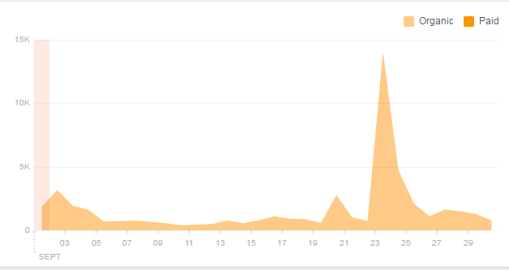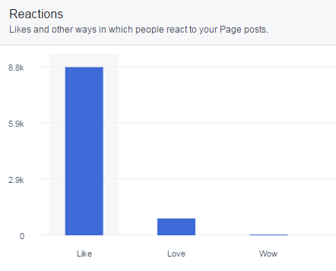

Last year we launched #Sheffieldfacesofrecovery social media campaign, with the aim to make recovery visible throughout the month, including a film about Sheffield people in recovery: https://youtu.be/CUySRaOF9Nc

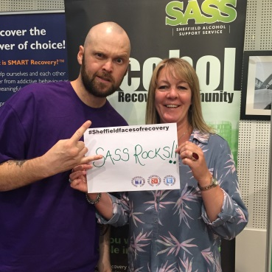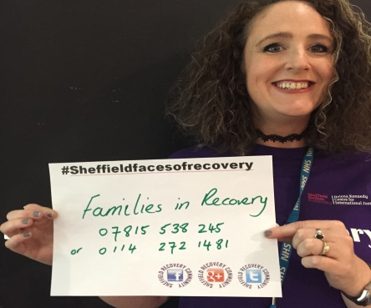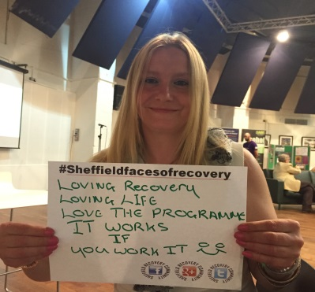

We are experienced in bringing people together to celebrate recovery, for example, every year we host a number of activities during recovery month, these include:
- Launch events
- Weekly recovery walks
- Alcohol-free music events
- Ride to recovery bike ride –over 100 people in recovery cycling around Derwent dam, donning our Purple recovery t-shirts
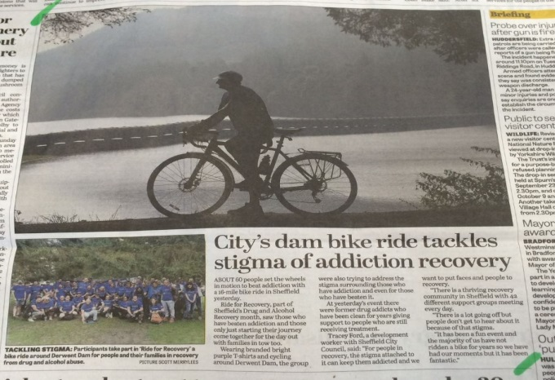
We host an annual recovery awards ceremony that celebrates people from across the recovery community. Last year we had over 35 nominations for the awards, with finalist in the following categories:
- Family and carer award
- Learner of the year
- Recovery initiative
- Volunteer of the year
- Workers choice

On behalf of Sheffield User Recovery Reference Group, thank you for considering our expression of interest

Yours Sincerely

Tracey Ford Tracey (Communities DACT)
Josie Soutar
CEO, Sheffield Alcohol Support Service

