[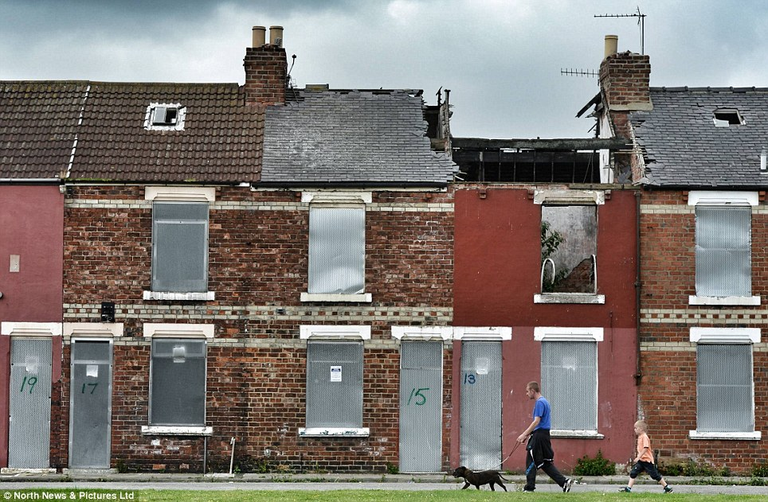](https://www.google.co.uk/url?sa=i&rct=j&q=&esrc=s&source=imgres&cd=&cad=rja&uact=8&ved=2ahUKEwiOwtuM__TbAhXGvhQKHcRBAoQQjRx6BAgBEAU&url=http://www.dailymail.co.uk/news/article-2397899/Community-transforms-Victorian-passageway-Middlesbrough-homes-oasis-greenery.html&psig=AOvVaw04egjNSN612yxUJcw3asur&ust=1530228385692724)

Walk the walk.

Why Middlesbrough needs the 2019 UK Recovery Walk.



About Middlesbrough.

Middlesbrough is an evolving town, perfectly positioned in the heart of the Tees Valley, in the North East of England. It has a population of 139,500, and attracts over 700,000 visitors from the surrounding areas of Tees Valley, North Yorkshire and County Durham who shop, work, study and enjoy the leisure attractions.

Middlesbrough has large scale outdoor events including Magical Middlesbrough seasonal events, live music festivals, and hosts the annual Re-Vive recovery Festival in August 2018

It has a growing restaurant scene and an independent quarter which includes Bar Zero and a number of unique eateries.

Middlesbrough Institute of Modern Art, a contemporary art gallery is located in the town centre.

The people are warm, friendly and extremely proud of their town, its industrial heritage and location close to the natural beauty of surrounding countryside and stunning North East coast.

Middlesbrough has invested heavily in regeneration with over £500M spent in the town, on landmarks like the transporter bridge, the college and University.

[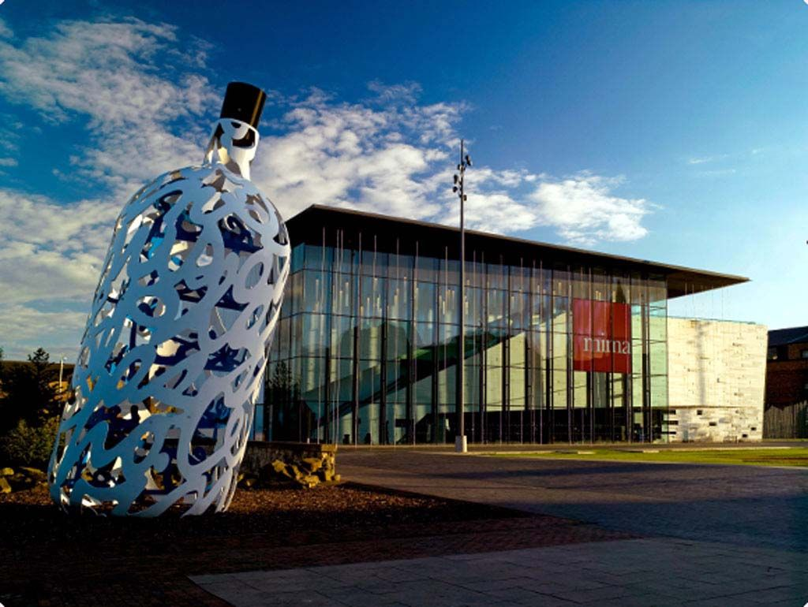](https://www.google.co.uk/url?sa=i&rct=j&q=&esrc=s&source=images&cd=&cad=rja&uact=8&ved=2ahUKEwiK84DK_vTbAhUCsxQKHecaC98QjRx6BAgBEAU&url=https://www.pinterest.com/pin/520306563174369293/&psig=AOvVaw0K2tVeZJjEwUA0sAaqTYLR&ust=1530228244636193) [](https://www.google.co.uk/url?sa=i&rct=j&q=&esrc=s&source=imgres&cd=&cad=rja&uact=8&ved=2ahUKEwizhMKdhPbbAhWQZ1AKHdNUCrkQjRx6BAgBEAU&url=http://www.visitmiddlesbrough.com/the-latest/story/3891/middlesbrough-mela-heading-home-to-albert-park-for-2018&psig=AOvVaw2zffZYjWBG7KeE2JOY3zpW&ust=1530264122595520)

Despite this Middlesbrough is still ranked as the 6th most deprived ward in the country and scores poorly across the board for health, lifestyle, life expectancy, education, employment, social mobility. The recent loss of major steel industry employer and supply chain decimated the recovering jobs market and has been a significant setback to the good progress recently achieved.

[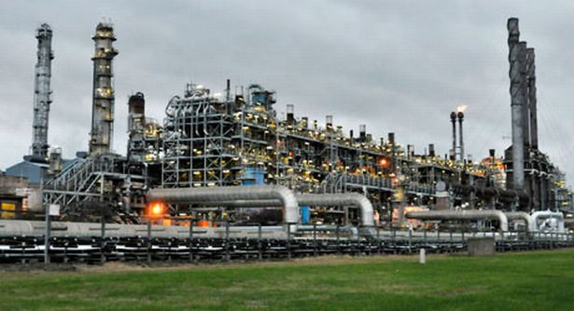](https://www.google.co.uk/url?sa=i&rct=j&q=&esrc=s&source=imgres&cd=&ved=2ahUKEwjip_H8qvbbAhVCrRQKHcUICzQQjRx6BAgBEAU&url=https://www.gazettelive.co.uk/news/local-news/bosses-unveil-10-point-plan-protect-3713015&psig=AOvVaw2l5rgcUCMYGI_DSGaQo3j8&ust=1530274523376057)

Services

Within Middlesbrough there are 1400 individuals at any one time in treatment through Middlesbrough recovering together.

Middlesbrough Recovering Together partnership consists of Foundations, CGL & Recovery Connections. Delivered across multiple sites across the town, the MRT offer ensures people can be picked up at any point in their journey and provided with a needs’ led service. Recovery is visible throughout the treatment journey via the Peer Ambassador programme.

Teesside University and Middlesbrough College – Are responsible for the health promotion and wellbeing of students. Both recognise the scale of the drug and alcohol issues in the town and are supportive and engaging with the commissioners and statutory services and recovery connections on collegiate recovery.

There are a number of other services which offer periphery support. These include Boro Angels support and soup kitchen, who are well networked within the recovery community.

The De Paul Trust have service user recovery groups and a forum.

We have a thriving mutual aid presence through Narcotics Anonymous, Alcoholics Anonymous and Cocaine Anonymous and Smart UK

The latest organisation to become involved is the social enterprise the Fork in the Road restaurant a project of Middlesbrough and Teesside Philanthropic Foundation Charity. This operation directly supports the community by offering training, volunteering and employment opportunities with a transitional model of employment. The profits that are generated by the restaurant allow Bar Zero; Middlesbrough’s dry bar, to operate above and offers a safe and relaxed place to socialise and undertake a range of activities, which are coordinated on behalf of the recovery community by recovery connections.

[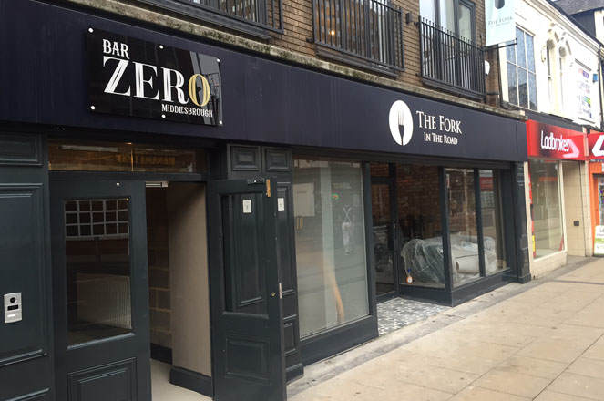](https://www.google.co.uk/url?sa=i&rct=j&q=&esrc=s&source=imgres&cd=&cad=rja&uact=8&ved=2ahUKEwifxvT0vfbbAhWHVRQKHZl4AlEQjRx6BAgBEAU&url=https://teesbusiness.co.uk/2017/01/18/teessides-only-dry-bar-set-for-big-launch/&psig=AOvVaw3aQWTuzolyhiMto2Bv-CTO&ust=1530279606586744)

Experience

The walk will be organised by a group made up of local representatives from the recovery community in Middlesbrough with some support from the previously successful Durham planning group. This will bring together the opportunities for co-production benefits such as increased planning skills, self-esteem, confidence, meeting new people, stronger voices, influencing skills for the group, whilst also being able to deliver against the criteria of successfully organising conferences and walks utilising the skills and knowledge gained from the Durham event to ensure that the expectation for a fantastic event will still be met and exceeded

The group will be able to draw upon additional expertise from within the Council specifically those involved with the organisation and planning of the multicultural Mela, we will also be able to call upon the expertise from the team who deliver the Middlesbrough 10K for route, permission and flow of people through the parks. CEO Sleepout who deliver high profile events nationally are also based locally and will be able to lend their support with promotion to the wider business community.

Recovery connections have hosted a number of recovery focussed events, celebrations and conferences at the scale sought for the recovery conference.

Why Middlesbrough

The North East had the highest drug misuse mortality rate in England in 2016, the most up to date figures are below.

**Age-standardised mortality rate for deaths related to drug misuse, by country and region, registered in 2016**

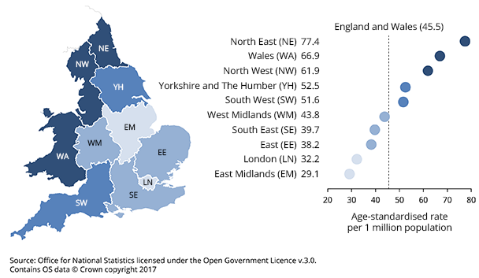

We are seeking to host the UK Recovery Walk as Middlesbrough has entrenched multigenerational drug and alcohol problems and beliefs that need to be challenged. One of the many ways we can do this together is through demonstrating and celebrating visible recovery, hope, belonging and feeling part of a movement. The conference will help to educate, raise awareness and show the work being undertaken both locally and nationally with the most up to date insights and innovation in the sector. The walk is a way of bringing individuals, families and the wider community together, offering opportunities for participation and creating connections, support and a legacy of good will that will support further progress.

By planning and undertaking the walk with support and guidance the group tasked with delivery will be learning valuable new skills and gaining experience, and confidence and self-belief that will directly benefit them and be transferable to other roles and situations.

Branding

Our branding suggestions are to continue with the theme of having the UKRW logo centrally and across all materials and publications as this creates and reinforces the already strong brand of the walk and message of putting your best foot forward.

We will offer a range of sponsorship options that are based on partnership and may include additional logo and branding opportunities which will sit alongside the UKRW logo.

We will scrutinise all partners and sponsors to ensure that there are only positive associations and will not work with alcohol/tobacco/pharma companies.

We will use the approved branding for cohesive messaging across all forums namely websites/social media, flyers, posters, adverts, banners, press and all merchandise.

The route

The walk itself will take in part the flowing river of the Tees and a number of the bridges, historical sites and points of interest in the town and will use mainly footpaths, pavements and has the option to finish in the town centre in the pedestrianised areas outside the council offices, combined Courts and Middlesbrough Institute of Modern Art (MIMA) or continue slightly further on to finish in Albert Park, depending on number of attendees, sponsors and exhibitors.

Middlesbrough, on the River Tees, has several outstanding bridges, which are the feature of this walk. The Newport Bridge was built by Dorman Long (who also built the Tyne and Sydney Harbour bridges) in 1934. The first vertical lift bridge in Britain (and the largest in the world), it was last raised in 1990 and is now permanently shut. But it is the Transporter Bridge that is the symbol of Teesside. Built between 1907 and 1911, it carries 750 people and 600 vehicles across the Tees every day on a carrying car that crosses in 2½ minutes, 160ft (48.7m) above the river.

The Tees Barrage, where the walk begins, was built between 1991 and 1995 at a cost of £54 million. It has four 50-ton gates, each 44ft (13.4m) long and 26ft (7.9m) high and has created 11 miles (17.7km) of freshwater between Stockton and Yarm that is used for a wide variety of leisure activities. The white-water canoe slalom course provides exciting sport, and hosted the Canoe World Championships in 2001.

From the Tees Barrage car park where we will be able to see the Stockton University Campus and Teesside park we will walk to the metal flags above the canoe slalom course. We will proceed through the walled picnic area to join the riverside path, and will follow this path, staying beside the river where the tarmac ends. We will go beneath the concrete road bridge, built in 1975 to carry the A19 road. After the bridge the path becomes a track and we head on towards the Newport Bridge.

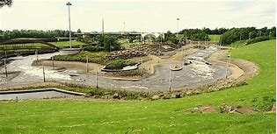

We will cross the bridge to descend the river bank on the far side enjoying the stroll along the riverside for 1½ miles (2.4km). This riverside park was once the site of the Newport Iron Works, founded in 1864.

The area around the Transporter Bridge has largely been cleared of the tightly-packed houses that once accommodated the thousands who toiled in the ironworks, but some still remain. Middlesbrough grew from a population of just 25 in 1801 to 91,000 a century later. It was called 'youngest child of England's enterprise, the infant Hercules'. Many of the houses the workers lived in were hard up against the ironworks, and their lives were dominated by smoke, dirt, heat and noise. Two-bedroomed houses could hold as many as 20 people, who slept and worked in shifts, so the beds were never cold. The women were condemned to a life of drudgery, trying to keep families together and prevent illness.

[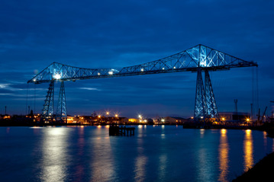](https://www.google.co.uk/url?sa=i&rct=j&q=&esrc=s&source=images&cd=&cad=rja&uact=8&ved=2ahUKEwikipXM_vTbAhWLbxQKHUn-BKwQjRx6BAgBEAU&url=http://www.lovemiddlesbrough.com/visitor-info/middlesbrough-in-a-minute&psig=AOvVaw2A4xHRhC37WakBg28bDM3R&ust=1530228248547479)

Across the river are the chemical complexes at Billingham, which opened in 1917. As the river curves right it is possible to see the wharfs where the iron ore barges tied up to supply the ironworks.

As we approach more modern office buildings we can see the disused slipways, where boats were once built, on the other side of the river. As we follow the path we arrive into an open area with steel sculptures of dinosaurs. This is Teesaurus Park, opened in 1982 on the site of a former slag heap. After this we emerge onto a road and follow this, bearing left at a roundabout, to reach a crossroads beside the Transporter Bridge. We continue onwards heading for the MFC stadium and the Temenos structure also passing the modern Middlesbrough college campus from here we cross under the railway lines onto cargo fleet road and start walking towards the Town centre. As we cross under the A66 we will catch a glimpse of the Parish Church of St John the Evangelist, and recovery connections HQ where there will be banners and well-wishers before crossing Russel street and heading to our finish in front of the MIMA building.

[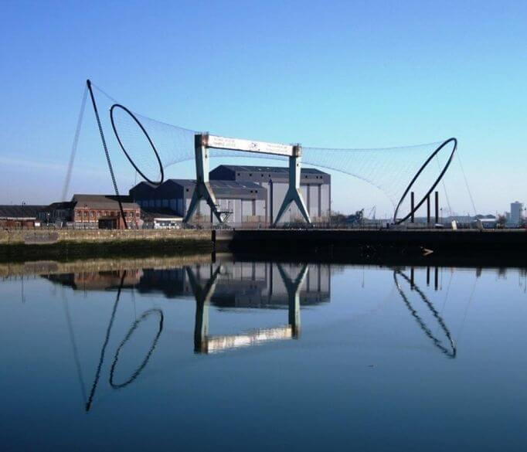](https://www.google.co.uk/url?sa=i&rct=j&q=&esrc=s&source=imgres&cd=&cad=rja&uact=8&ved=2ahUKEwijpqXh_vTbAhUBxRQKHWvpCsYQjRx6BAgBEAU&url=https://www.treasuretrails.co.uk/things-to-do/north-yorkshire/middlesbrough&psig=AOvVaw2yxiKY-1lS2WnEjdp_XOFy&ust=1530228294082761)

There is a café and toilets at the start area along with ample car parking. The route is under 3 miles and does not have any steep gradients. There are a number of places to eat and drink in immediate proximity to the finish area and public toilets in the Cleveland centre.

Optional ending

Albert Park in Linthorpe Road, Middlesbrough, is a green oasis in the town. There is a visitor centre and areas for sports and games, as well as beautifully planted flowerbeds. The refurbished Dorman Museum in the park, built after the only son of the Dorman shipbuilding family died in the Boer War, has displays of Middlesbrough history.

[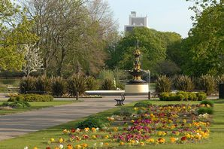](https://www.google.co.uk/url?sa=i&rct=j&q=&esrc=s&source=images&cd=&cad=rja&uact=8&ved=2ahUKEwidz5ikwvbbAhUEbhQKHUUiDE0QjRx6BAgBEAU&url=https://www.gazettelive.co.uk/all-about/albert-park&psig=AOvVaw2uWVj5P2gDzvUkuTEP1m_O&ust=1530280715141901)

Support

Public sector agency support will be considerable for a project of this size. We will work with all partners to ensure we have an exceptionally vibrant finish area that is busy with stands, activities and things to do for the participants and the wider community and visitors. At the start we will have a numerous banners a gantry and some press.

We will ensure that allied services are represented with colleagues from health and other departments invited to exhibit and participate. We will work with our festival organisers to ensure we have artists, musicians and entertainers in attendance to make the event something to be remembered.

We will have volunteers and other supporters who will help to marshal and signpost the route, ensuring safety and that no one can be lost of left behind.

We will work with specific agencies for first aid/paramedic cover and security.

Getting there

Tees Barrage is a single stop from the main Middlesbrough train station to Thornaby station and is a short 5 minute walk down a single straight road.

The closest commercial airport is Durham Tees Valley international which is also on the A66 you would take this road or public transport straight to Teesside Park shopping centre, or Durham University Queens Campus where it is possible to walk directly to the starting point. From Newcastle airport a train would be required to Middlesbrough station followed by the above single stop.

Finding Tees Barrage couldn’t be easier as it is perfectly situated just off the A66 and A19 between Middlesbrough and Stockton. There is ample free parking on site for cars and coaches and the surrounding area also has plenty of free parking options.

BY CAR

Sat nav reference: TS17 6QA

From the North or South – Follow the A1(M) and join the A19. Turn onto the A66 signposted Darlington and take the exit signposted Teesside Retail Park. Follow the brown tourism signs to Tees Barrage.

From the East or West – Join the A66 and take the exit signposted Teesside Retail Park. Follow the brown tourism signs to Tees Barrage.

BY TRAIN

Our closet station is Thornaby, but both Middlesbrough and Stockton are within 3 miles. Tees Valley has excellent rail services with trains from London in less than 3 hours.

For 24-hour train information you can call (UK – everyday except Christmas Day) 03457 48 49 50 (International – international rates apply) +44(0)20 7278 5240

or visit:

www.tpexpress.co.uk

www.nationalrail.co.uk

www.virgintrainseastcoast.com

BY BUS

Reliable coach travel is available across the country on the National Express Service.

Call +44 (0)8717 818178 or visit the www.nationalexpress.com

For dedicated general travel information across Tees Valley, including local bus and taxi information visit www.connectteesvalley.com

BY BIKE OR ON FOOT

Cycling and walking are some of the best forms of exercise for overall fitness – So why not travel to the TBIWWC by foot or cycle, we have excellent path and cycle path systems that bring you right to us.

BY BOAT

With moorings available for use to visit Tees Barrage all year round why not avoid the hullabaloo and travel by boat? RiverShack also operate a daily river boat between Preston Park, Yarm and the Tees Barrage (depending on weather conditions), for more information call RiverShack on 07795613299

or visit:

www.rivershack.co.uk

[www.facebook.com/RiverShackTees](http://www.facebook.com/RiverShackTees).

Accommodation

There is a range of accommodation in Middlesbrough comprising guest houses, B&B’s and Hotels with prices starting from as little as just £17 per night.

The closest accommodation to the start area is the Premier Inn Whitewater Way, Thornaby, Stockton-On-Tees, Stockton-on-Tees, TS17 6QB, United Kingdom with rooms starting from as little as £29

The end being central has far greater choice with also the widest range of pricing with the Holiday Inn Express and Jury’s in both being £59.

There are also other multiple options available with Air B&B. The Dry Bar has agreed that we can offer a sleepout option for a donation of £10 per person making it more accessible to everyone.

[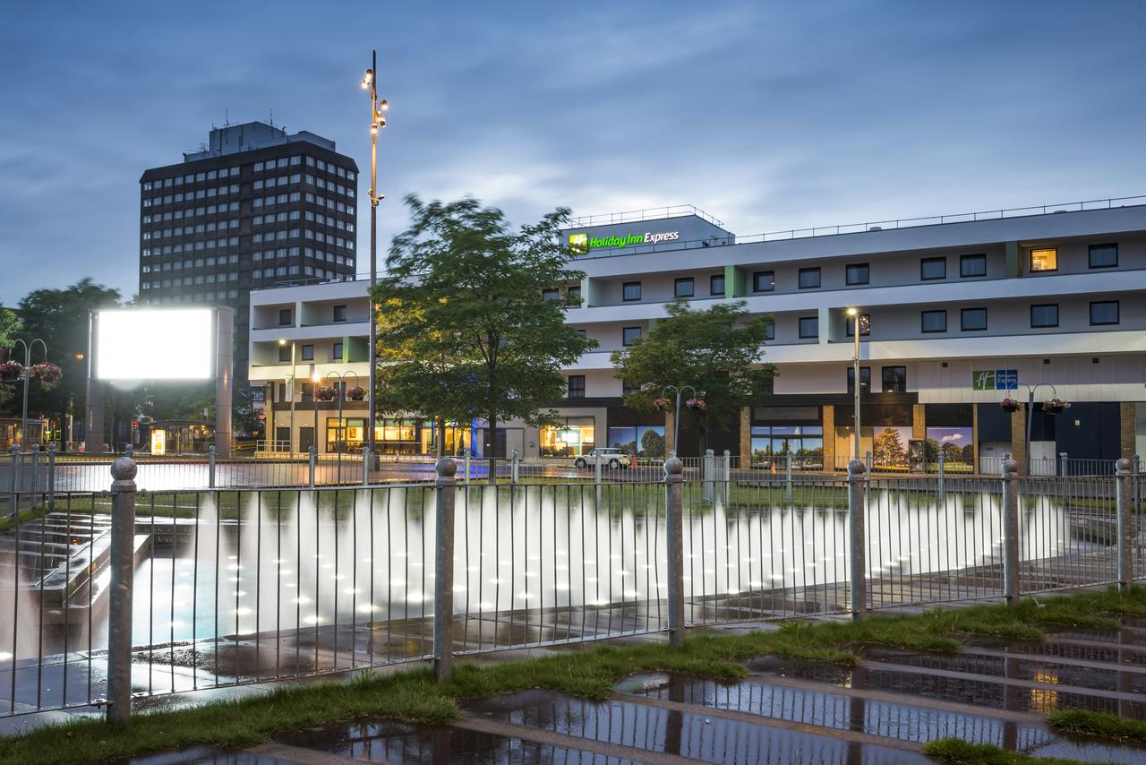](https://www.google.co.uk/url?sa=i&rct=j&q=&esrc=s&source=imgres&cd=&cad=rja&uact=8&ved=2ahUKEwiJnpXb_vTbAhUJtRQKHU1pAHYQjRx6BAgBEAU&url=https://www.booking.com/hotel/gb/holiday-inn-express-middlesbrough-centre-square.en-gb.html&psig=AOvVaw1d0L2Kg6ctrhQYKE1Y9dfv&ust=1530228281612252)

The forecast budgets, in Excel-file format, are attached showing clearly the conference registration fees and projected income and expenses.

UK Recovery Walk Conference

TheConference registration fee as included in forecast budget is at the rate of £50 for professionals, £10 for friends of recovery and £10 for those in recovery.

We have illustrated scenarios where we have 50 delegates made up of 15 professional and 35 recovery places (minimum attendance). Break-even is with 150 places with 100 professional and 50 recovery places. Lastly high attendance is 350 places with 150 professionals and 200 recovery places.

The Conference venue we have selected is Teesside University. We are able to hire the forge and lecture theatres exclusively which gives us access to business rooms and meeting space including a welcome area in the foyer.

Seminar suite including learning lounge and outdoor terrace

Seminar rooms x 2

Executive boardroom

One large business meeting room

This would give us the necessary 350 capacity.

Other venues locally that can manage the same numbers are the jury’s Inn and Middlesbrough Football Club stadium both of which accommodate 350 delegates have full conferencing facilities but are both more expensive.

Accommodation has already been listed above in the walk depending when held there may also be the possibility of student accommodation from £12 This is in the same location as the start of the event and so the directions for travel are also exactly the same as listed above in the walk section.

This could be a transformational event for the recovery community we would like you to walk with us on this journey, on our route to recovery.

