Taking Steps to grow together.
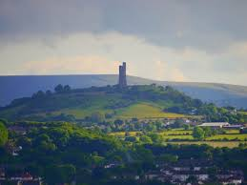
A town in West Yorkshire with a burgeoning and flourishing Recovery Community welcomes thousands of people with colour, drums and something in common….

Huddersfield welcomes Recovery.

Part A: The UK Recovery Walk.

Introduction
This is the product of a few dedicated people wanting to ensure that a voice is heard and that the people in Kirklees are able to see that the face of addiction and recovery is one that is not fixed to a stereotype and is a human doing human things. So after various discussions in meetings and groups, one individual said, Can we bring the noise of Recovery to Kirklees and show Kirklees, West Yorkshire and the UK that the talents, skills, assets and capabilities are just as prominent as anywhere else in the UK and the World.
The group that put this bid together are Taking steps together to grow together.

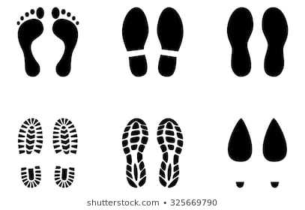
The group that contributed and put this together are members of the Recovery Communities in Kirklees and gave up their time to take an idea and start to put it into reality. We as a group believe that,
Never doubt that a small group of thoughtful, committed citizens can change the world. Indeed it is the only thing that ever has.

The local Community – Estimated size, Service Support, Group and Meeting Support?
What does Recovery look like in Huddersfield? It looks the same as anywhere else from a personal and individual perspective. From the other side of the service counter it looks like s a partnership between CGL(Change, Grow, Live), The Basement Recovery Project and Community Links and is called CHART (Choices in Health, Addiction, Recovery and Treatment) Kirklees. The treatment offer is fairly similar to lots of other services across the country and includes areas of service such as;
- Assessment and Engagement
- Triage
- Criminal Justice
- Complex Case work
- Recovery Co-Ordination
- Structured Group Programmes
- Psychosocial Interventions
- Counselling
- Family Development
- Volunteering
- The Wellbeing Wheels Outreach Van
To add to the above, there is a full Mutual Aid programme across Kirklees and a heavy focus on Visible Recovery via the Peer Mentoring and the Warrior Down ethos deployed by The Basement Recovery Project. The visible Recovery is also heavily represented in the volunteering aspect of the whole service as many volunteers utilise their experience to better influence and model good recovery behaviour and values.
How does this look in numbers? CHART has an average of 1800 people accessing its various services at any one time and an average of 600 people exit the service yearly back out into the community. CHART has good links with Detox and Rehabs and part of the service offering is ambulatory detox that has a clinical foundation. Across the district there are about 20 Mutual Aid that cover AA/NA/CA/SMART Recovery and Al Anon and carries attendances of 15+ consistently for some of the more established meetings. Access to Mutual Aid is facilitated by staff, volunteers and Peer Mentors across the partnership and all staff at The Basement are heavily invested in Mutual Aid as it complements the CHART service offer.

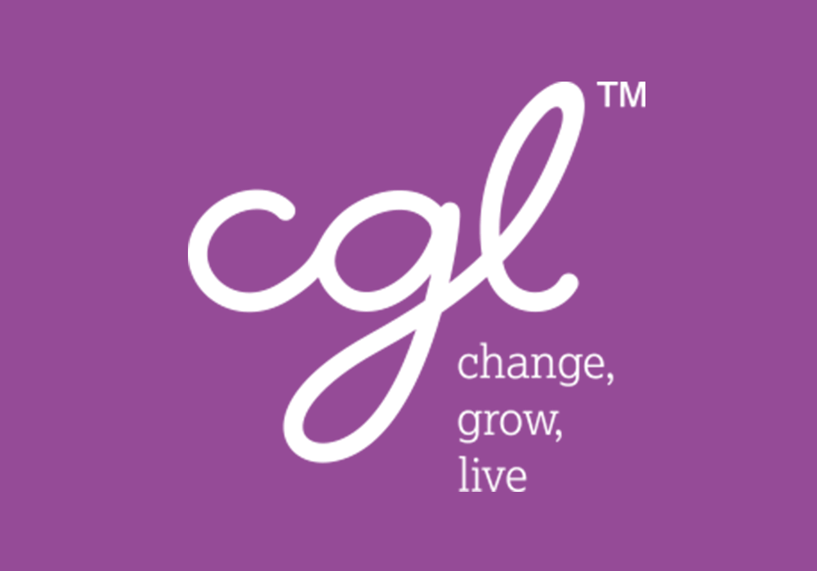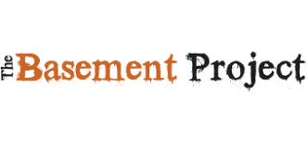

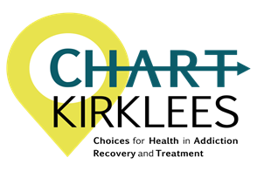
Additionally there are other Recovery support services and groups such as Colne Valley Addiction Support, Haven, Kirklees In Recovery and CLEAR (Community Links Engage and Recover) as well as presence from services such as WY-FI (West Yorkshire Finding Independence). To complement the services that are commissioned there are a lot of citizen activated groups that feed and signpost the homeless community and work in partnership with local provision.
Other support on offer in Kirklees covers such things as the food banks that are faith based and completely volunteer run, Wellbeing and Dementia cafes that are provision of partners and independent groups such as Platform 1 and Andy’s Man Club and the Kirklees Recovery College that is part of the local NHS trust. Recovery has a visible presence in Huddersfield and there are lots of people working in partnership to ensure that people are able to access the services and enable the right kind of support to continue growing.

Experience organising Events, Conferences etc?
Before mentioning the team that will organise the walk, the experience in the services that will support both the bid and the development of the walk is untold. CGL are a large provider and offer their expertise should it be required from social media presence to support in any other area. Locally we have had a couple of walks in the past few years with a view of undertaking this bid at a later date and this gave a good insight into what has to be taken into consideration, what can go wrong and what skills add value.
The team has experience in many areas, both in a professional and personal capacity. The members of Kirklees in Recovery regularly put on Recovery Events for the Community at the Union Bank Hub and are well versed in different ways of fund raising in the community that highlight Recovery in a positive light. From Recovery’s Got Talent to Christmas parties to locality based conferences, it is client and recovery led and builds on the skills available in the community. There is experience of facilitating networking events for health care professionals to community building events that allow people to bring their own gifts to the table to support others as well as having the ability to work with diverse communities via the Community Champions that work with the South Asian Community.
We have additional skills to call upon from the local authority who put on events locally such as Carnivals, Pride and sporting events. To bring it all together there are some Asset Based Practitioners who understand how to tap into the skills and assets and bring them to the fore to build and develop a walk that will be talked about for years to come. Working in this way will enable upskilling, supportive ways of working and develop confidence and self esteem as well as employability skills that are there and working in a co-productive way will build community cohesion and by default and positive ways of working, bring the community closer together with a shared aim and vision.
People take ownership of the things they help create.
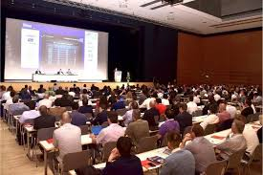

There are a depth of skills, creativity, knowledge and contacts that have already been used to tell the good story of Recovery and whilst we are confident in our abilities to develop this Walk, we are honest enough to know that one of the biggest bits of experience we can bring to the table is that we need help to deliver and where we might have a limitation due to lack of experience or knowledge, we have a good pool of invested people to come along and support the development.

And why Huddersfield?
Huddersfield, if successful, would be the first National Recovery Walk to visit West Yorkshire and as such has the ability to capture attendance from the most built up area, a population of 2.5 million people, outside of London within thirty minutes drive. It is central and has good access and has good history, culture and scenery. The locality has some very diverse communities and the walk would highlight the cultural diversity in the recovery community. There is a large University population where drink and drugs is part of the culture and the walk would highlight that everybody can be affected by addiction and there is a fulfilled life on the other side of addiction.
As there are some long term people that have less exposure to Recovery because of cultural, generational and geographical issues, the ability to reach the harder to reach by way of the walk, as it has done in previous years, is a positive reason to see Huddersfield as a viable option for the walk. Reaching the harder to reach will be our driver.
The conference will have a focus on Inclusion in Recovery and highlight some of the work being done locally and nationally to bring Diversity to the forefront and present a united and Inclusive front in times where difference can be viewed negatively. The walk and the conference will raise awareness, provide information and evidence and insight and offer opportunities to feel part of something bigger than the individual. Huddersfield has many reasons to host the walk, from its history to its culture but the biggest reason is that the community are ready to show the world that no matter the town or city, Recovery isn’t a myth, it’s a reality.
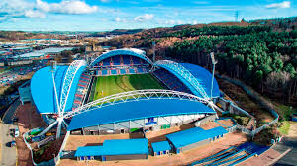

Any branding for the Walk?
The branding for the walk would consist of the Recovery Walk logo as the foundation and will serve to maintain the recognition of the brand and its brand identity. All other logos and branding would come from partners and supporters and will be given the due diligence to ensure matching values and ethos. Any branding will promote a singular message and will build a package that can be used on social media as well as on publications and materials.
The Route…
In previous years the Walk has worked as it has maximum impact in terms of visibility and the route for Huddersfield was discussed with the same driving principle….How do we capture as much impact as is possible?
The walk would start at John Smiths Stadium which is a historic venue and the birthplace of Rugby League and the home of both Huddersfield Town and Huddersfield Giants. From there the walk would skirt the industrial area of Huddersfield and walk along the Ring Road, past the Lawrence Batley Theatre to Huddersfield University so as to be visible to workers in industry as well as shoppers visiting the many large shops that skirt the centre of Huddersfield. This also will promote visibility with the student population before aiming to hit the main shopping drag in Huddersfield centre.
From the University the Walk will travel up the Plaza past the Town Hall and onto New Street and proceed to walk the ½ kilometre to the front of Huddersfield Train Station and the historic Harold Wilson Statue. This gives visibility to all the shoppers that will be in Huddersfield on a Saturday afternoon and by walking via the train station, we will also be visible to any commuters that are routing at a very busy connecting station that sits in the middle of the M62 train route.

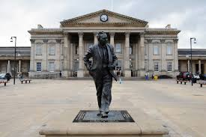
From there the walk would walk past Brian Jackson House and cross the ring road and past the College and up to Greenhead Park to a place where lots of people visit with family for the scenery but it also provides a venue for the celebration that caps the walk. The walk itself is no more than 2 miles and takes around 35 minutes to walk at a leisurely pace as a singular person.

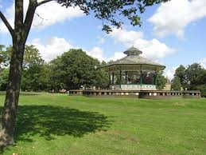

The Community Support?
To put on the Walk and everything it includes, the support in development would come from the existing Service User Forum and Kirklees in Recovery to drive the development forward as they are the Recovery Community that is currently active and visible. We will also work with partners that have similar aims and extend invites to other recovery focussed groups that have a vested interest such as Colne Valley Addiction and The Recovery College as they are very active and work with a view of Co-Production and Asset Based Approaches.
Support from Public Sector Agencies?
As we know from previous ventures and the experiences of the group in previous work, any outdoor event requires lots of buy in and this is no different. We will work with all the relevant Agencies to ensure the delivery of this project. There will be a requirement to work with the Police and the Local Authority to ensure the route is viable and can be used as well as to close any roads at the time of the walk. We will work with the emergency services to provide support on the day should anything require their attention as well as working with St Johns to provide first aid support on the day.
Initial contact has been made via the commissioners to the local authority and there is verbal support so far and we have a list of councillors that we will approach to improve the buy in as well. We have also approached the local trust as they are very visible in the area and have a vested interest in reducing admissions to primary care and A and E so the Walk would have impact.
There is support from the services in the area such as Community Links, Better in Kirklees and The Mission and the group feel that closer to the time, when it comes to raising funds, support from the Huddersfield Town/Giants Community Foundation, as well as other local sporting teams will be accessible.
We will also cash in on our contacts and include other agencies such as Huddersfield University, Locala CIC, Local Businesses and Folly Hall as we believe that the impact from people finding recovery is immeasurable and hits lots of other agencies so we feel they have a vested interest in this project.
Forecast Budget – to include projected income, Expenses and the Conference?
Please find attached.

Part B: The UK Recovery Walk Conference.

The Conference.
The Conference theme will be Inclusion in Recovery as it is a theme that a lot of the group are passionate about and carry as a personal value. The reasoning behind this is that it offers the opportunity to showcase some of the work that is happening in the LGBTQ community and around chemsex as well as showcasing the work that is often unheralded in communities such as the South Asian and Caribbean Communities with the BAME (Black, Asian and Minority Ethnic) network and Community Champions.
Speakers will be picked by the group and will keep in theme as well as follow previous conferences and offer opportunities for those in the recovery community at different stages of their journey the chance to inspire others.
The aim of the Conference would be to highlight that Diversity is vibrant and visible in recovery and there are people and projects out there devoted to improving and highlighting that. Another aim would be to challenge the Hard to Reach ideal that is banded about a lot and to prove that stigma can be challenged and broken in varying ways.
Registration fee?
Taking into account previous conferences and the hope of attracting a diverse range of attendees, the price structure will be as follows;
£50 for professional delegates
£10 for friends/family of those in recovery and £10 for those in recovery.
We would also like to ensure that we can raise a small pot to include spaces for the unwaged in Recovery.
The venue – Number of meeting rooms, seating capacity, rental price, facilities available on site?
The venue is a conference centre at John Smiths Stadium that can fit up to 440 delegates with Theatre Style seating. There is the option of having some break out space in some of the grounds hospitality boxes which fit up to 20 people in. There is WI-FI, car parking and screens included in the pricing plan.
The price for the Revel Ward is £875 for ½ day and £1500 for the full day.
The additional price for equipment (PA System and screens) is £231 for 1 screen and £280 for 2 screens. (Event Management is included in the hire price)
They do charge for catering at £7.79 per head although the group feel that it may be an option to access a caterer that is local and part of the Recovery Community.
(Other local options include Lawrence Batley Theatre, Brian Jackson Hose and Cedar Court Hotel that have the ability to put on a conference to cater for up to 200 people at similar prices).

Three scenarios – Minimum attendance, break even and high attendance.
 | Scenario 1  Break Even | Scenario 2  High Attendance | Scenario 3  Low Attendance
Professional Delegates | 40 X £50 = £2000 | 100 X £50 = £5000 | 25 X £50 = £1250
Friends of/Recovery | 28 X £10 = £280 | 50 X £10 = £500 | 15 X £10 = £150
Total | £2280 | £5500 | £1400

Housing/Accommodation – Rates and category of rooms, access to town (air, road, rail etc)
As with most towns that have a bustling shopping area, Huddersfield has various hotels, Bed & Breakfasts and accommodation that range in price. There is a Travelodge (Leeds road), which would be the closest to the Conference and start point of the Walk within 1km of the centre that averages room pricing at £50 (on date of writing this). On the outskirts of Huddersfield there are some bigger and more luxurious Hotels such as Clarion Cedar Court which starts at £48 per room.
Other local hotels include Townhouse No12 at £50, Ashfield Hotel at £44 and Edgerton Hotel at £55. A basic Google search would give around 100 different hotels and B & B’s across Kirklees. Another option for overnight stay is Air bnb which has 300 + places to stay listed at the time of writing this
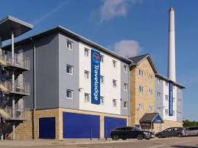
Travel access to Huddersfield is very good. There are 3 airports within 30 miles, Leeds and Bradford, Manchester and Doncaster Sheffield. These all support Internal flights from most destinations in the UK and International flights as well.
To access by train is easy as Huddersfield sits between 2 major Rail cities in Leeds and Manchester and is on the main M62 line so allows for access from all over the country in terms of train travel and is mostly one change from far out stations. The station is managed by Trans-Pennine and is renowned for its world famous Cat, Felix. www.tpexpress.co.uk is the best source of information for trains in and out and the station is central and 1km away from the start of the Walk and the Conference.
Huddersfield is connected to the national motorway network via the M1 and M62. The M1 passes to the east of Huddersfield (about 10 miles) and the M62 passes about 2.5 miles to the north of the town. The junctions that serve it are 23 (Mount), 24 (Ainley Top) and 25 (Cooper Bridge).
There is also coaches that drop and arrive here via www.nationalexpress.com and there are buses that hit Huddersfield from all over the West Yorkshire County www.arrivabus.co.uk
If you choose to cycle here then we are connected via the canal and Huddersfield Greenway which has exit points right next to the stadium.
The group that are driving this forward would like to offer their services in developing the Huddersfield Walk if we are to be successful and would hope that We get to take steps together to grow together.
Thank you

